**Heuristics for Vertex Transitive Non Hamiltonian Graphs**

There are no self references in these graphs

V={2,10,28,30,84} This Number sequence may be a Closed Form

E={1,15,42,45,126} This Number sequence may be a Closed Form

https://www.wolframalpha.com/widgets/view.jsp?id=d9976f1c2c0c972d1cee0c3647cbd194

With the exception of the trivial graph (2V) all V have degree of 3

Number of V is always even.

The graphs are derivative they are closely related.

The number of E is not relevant as it can be derived as the Sum of E is twice the Sum of the Degree

The trivial graph is excluded here.

Vertex Degree Edges Graph Type

10 30 15 Peterson

28 84 42 Peterson Triangle Replaced

30 90 45 Coxeter

84 252 126 Coxeter Triangle Replaced

Using a Difference table (<https://alteredqualia.com/visualization/hn/sequence/>)

The sequence that this suggests might have some chance of generating a VTNH graph.

V={2,10,28,30,84,**352,1090,2648**}

These numbers **352,1090,2648** are all even so they look promising (it must be admitted that any even number multiplied by 3 will give an even number).

When examined these numbers do not conform to a Closed Form

The new Vertex Degree and Edges are below assuming the 3 degree heuristic still holds.

Vertex Degree Edges

10 30 15

28 84 42

30 90 45

84 252 126

**352 1056 528**

**1090 3270 1635**

**2648 7944 3972**

Given that Triangle replacement worked any shape with an odd number of points may work.

The sequence **352,1090,2648** should be a sub shape or shapes which has an odd number of points.

These sequence may not be valid given this but they will be tried. If 5 sides shapes are used then the degree of each vertex may need to be 5 and not 3.

The constraints seem to be:

1. Number of Vertices must be even.
2. Each vertex must have the same degree.
3. The degree of each vertex must be 3 or maybe another number.
4. Self Reference is not allowed.

**The Peterson Graph**

If you cycle the numbers of the nodes you get an interesting duplication for the adjacency of V0

The colours of the numbers are there to make this easier to understand. As can be seen there is appoint at which the adjacency repeats for V0. This suggests the cycle does not exist.

BLK V0 1,4,5 RED V0 7,8,5 BLU V0 5,7,8 GRN V0 2,5,8

**PRP V0 2,3,5 * RNG V0 2,3,5 \***

YEL V0 5,6,9 GRY V0 1,4,9 WIN V0 1,6,9 PNK V0 1,5,9

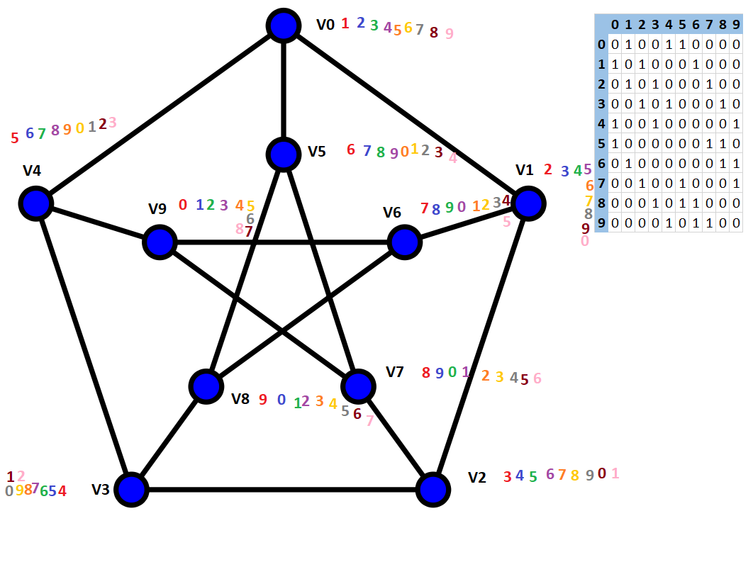

This is a 2 regular graph with an odd number of verticies.

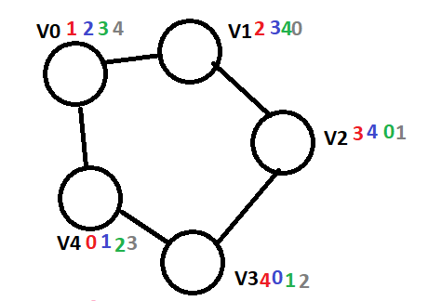

BLK V0 1,4 RED V0 1,4 BLU V0 1,4

GRN V0 1,4 GRY V0 1,4

As the vertices are rotated they adjacencies remain the same.

This is a 2 regular graph with even number of verticies.

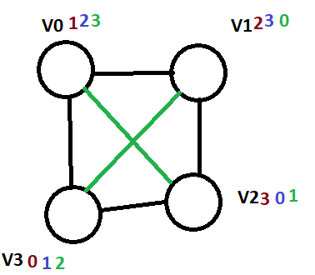

BLK V0 1,3 RED V0 1,3 BLU V0 1,3 GRN V0 1,3

Irregular Odd Number of verticies

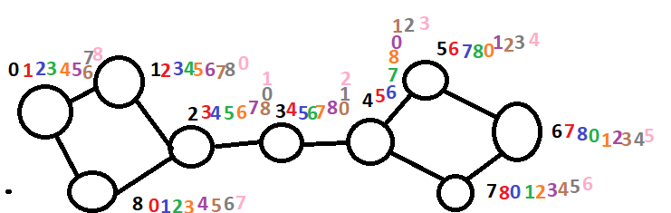

BLK V0 1,8 RED V0 1,3 BLU V0 8,6 GRN V0 1,8 RNG V0 1,8 PRP V0 1,3,8

BRN V0 1,8 GRY V0 1,6,8 PNK V0 1,8